Resistors and Basic Information
(Final Report – Experiment #1)

Vega, Roberto Javier SID: 003 110 717
Partner: Eddie Esquivel
EE 110L
LAB 1
Objectives:

-To learn how to use the DMM to measure resistances
-To learn he DC shunt milliammeter to measure DC currents
-To understand how the DC shunt milliammeter works and how it disturbs the circuit being measured.
-To learn the color code and power rating for resistors
-To demonstrate the Ohm’s Law.

Theory:

-Ohm’s Law: V = I R
-Voltage Divider: V₁ = V (R₁ / (R₁ + R₂))
-Current Divider: I₁ = I (R₂ / (R₁ + R₂))
-Power: P = V² / R.
-For the DC shunt miliammeter: I = I_{meter} ((R_{shunt} + R_{meter}) / R_{shunt})

Procedure:

- Pick a resistor having resistance between 47Ω to 50kΩ and read its resistance, power rating and tolerance. Calculated the largest voltage safely applied to it.
- Set up the circuit as it was indicated in the manual. Then measured the voltage across the resistor by the DMM, and determined the current in the circuit from the reading of the milliammeter.
- Replaced the resistor in the circuit with a 50Ω – 100Ω resistor. Then increased the voltage in steps of 1, measured the current for each voltage, and calculated the resistance, until I cannot pinch the resistor (too hot).
- I replaced the resistor in my circuit with a resistor between 100Ω and 500Ω, and I set the power supply to get a total current of 0.8mA in the circuit. Then I measured the voltage across the resistor and the current with a short shunted milliammeter. After that, I removed the milliammeter from my circuit and measured the voltage.
- I replaced the resistor with the light bulb and used the smallest shunt resistor in the milliammeter. Then, measured 10 voltage–current pairs, up to 6 volts.

Pre Lab Calculations:

1.
 | Shunt Resistance | Maximum Current
 | Small shorting block | 1 mA
 | 4.8 ohms | 10.0 mA
 | 1.8 ohms | 25.2 mA
 | 1.0 ohms | 44.5 mA
 | 0.173 ohms | 252.5 mA
 | 0.0862 ohms | 505.64 mA

2.

 | Voltage | I₁₀₀ | I₁₀₀₀
 | 1 Volt | .01 A | .001 A
 | 2 Volts | .02 A | .002 A
 | 3 Volts | .03 A | .003 A
 | 4 Volts | .04 A | .004 A
 | 5 Volts | .05 A | .005 A

3.

 |  | I | V₄₃ | V₄₇ | V₁₀₀
 | 47 ohms | .01 A | .48 Volts | .52 Volts | ------
 | 100 ohms | .007 A | .30 Volts | ------ | .70 Volts

Data Obtained Experimentally:

1. A. 4,7000 ohms, 5%, 1/4W
B. 4,300 ohms, 5,100 ohms
C. 4,615 ohms, uncertainty = 4,700 – 4,615 = 85 ohms
D. P = v²/r => v² = Pr => v = (Pr)^{1/2} = 33.9 Volts

2. A. 10 volts R = 4,700 ohms
i = v/r = 10/4,700 = .0021A = 2.1mA
-Internal resistance of milliammeter is 43.5ohms
-Need to use 4.8 ohm shunt
-Power supply voltage => V=ir = (2.1mA)*(4,735.5ohms) = 9.96volts
D. 10.95 volts
E. .24mA shown in milliammeter
I = (.24mA)*((4.8 + 43.5)/4.8) = 2.4mA
v/r = 10.95volts/4743.5ohms = 2.3mA
F. uncertainty of I = 2.4mA – 2.3mA = .1mA

G.
 | V | I in Milliammeter | I = I_{m}(4.8 + 43.5)/4.8 | r = v/i
 | 8.9V | .20mA | 2.0mA | 4,450 ohms
 | 7.1V | .17mA | 1.6mA | 4,444 ohms
 | 4.0V | .09mA | .90mA | 4,522 ohms

3. Shunt => .173 ohms 68 ohm resistor

 | V | I = I_{m}(.173 + 43.5)/.173 | R = V / I
 | 1.05V | 15.7mA | 66.5 ohms
 | 2.01V | 30.3mA | 66.3 ohms
 | 3.00V | 45.39mA | 66.1 ohms
 | 4.10V | 62.12mA | 66.0 ohms
 | 5.00V | 75.76mA | 66.0 ohms
 | 6.03V | 91.64mA | 65.8 ohms
 | 6.96V | 105.90mA | 65.7 ohms
 | 8.07V | 123.39mA | 65.4 ohms

4. A. 220 ohms, voltage across resistor = .175V, I = V/R = .175V/220ohms = .79mA
B. Voltage across resistor = .209V

5. Shunt = .0862 ohms

 | V | milliammeter | I = I_{m}(.0862 + 43.5)/.0862 | R = V/I
 | .592V | .21mA | 106.18mA | 5.58 ohms
 | 1.040V | .26mA | 131.47mA | 7.91 ohms
 | 2.080V | .36mA | 182.03mA | 11.43 ohms
 | 3.055V | .44mA | 222.48mA | 13.73 ohms
 | 3.995V | .50mA | 252.82mA | 15.80 ohms
 | 4.583V | .55mA | 278.10mA | 16.48 ohms
 | 4.950V | .57mA | 288.21mA | 17.17 ohms
 | 5.675V | .62mA | 313.50mA | 18.10 ohms
 | 5.995V | .64mA | 323.61mA | 18.53 ohms

Data Analysis:

In the first part of the experiment, I was checking the resistance indicated by the resistor’s color code and the resistance measured by the DMM. The resistor I picked was 4.7Ω and 4,615 Ω measured by the DMM, and the range of resistance given by the manufacturer was within the range of resistance measured by the DMM. This showed that the resistance given by the manufacturer was not exactly the resistance of the resistor. This could be due to the aging of a resistor.
In the second part, I was checking if I = V / R. The current measured was 2.3mA while the current obtained from dividing measured voltage by measured resistance was 2.4 mA. The range of current measured by the milliammeter was within the range of current calculated from measured voltage and resistance. Although the two currents were not exactly equal to each other, it was reasonable because the calculated current did not taking the internal resistance and the shunt resistance of the milliammeter into account.
In the third part of the experiment, I was feeling the heat dissipated by a resistor. I also recorded the voltage and current through the resistor and plotted the graph V vs I. The highest voltage I could still bear the heat of the resistor was 8V, and the power was 1 watt.
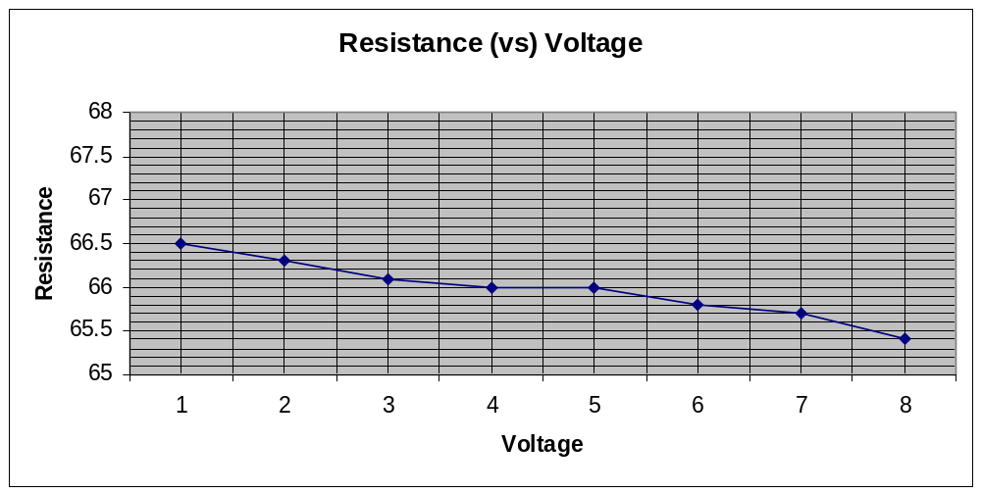
In the forth part of my experiment, I was observing the effect of the milliammeter in my circuit. With it in the circuit, the voltage across the resistor was .175V, while the voltage was 0.209 volts after removing it. This made sense because the resistance of the milliammeter would take a little share of the total voltage applied to the resistor. With a short shunt, the total resistance of the milliammeter was 43.5 Ω.

In the fifth part of my experiment, I was checking if the given light bulb was violating the Ohm’s Law, V = IR. From the data I recorded, I plotted a graph of V vs I. The slope, which was V/I = R, was quite constant. As a result, I would say the light bulb was not violating the Ohm’s Law.
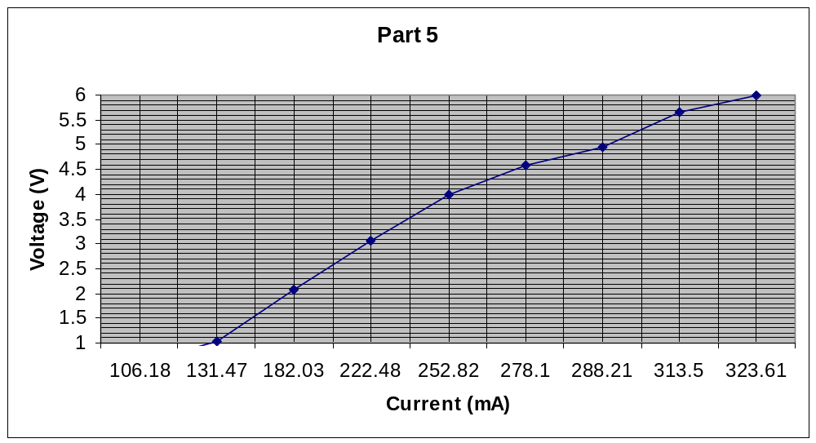

Discussion:

1.- How much electricity does it consume in kilowatt-hours? 4.6KWH
Estimate, in dollars, what it has cost UCLA to provide you with this amount of electric energy? 28cents
Have you gotten a good deal for your tuition payments? Yes
Did the light bulb violate Ohm’s Law? No
Explain. This is because as more voltage is applied to the bulb increases the amount of heat that is dissipated.

2. That is because the miliammeter will not work with out that third part that connects the circuit. That part warranties that when somebody removes the resistor they also disconnect the circuit, so a short can’t damage the miliammeter.

3.
8 volts
1 Watt
R: 68 ohms, Power: 1 watt.

4. Because the resistance of the milliammeter causes the voltage drop to be less across the resistor.

Under what circumstances is the disturbances produced by the ammeter important?
When you need exclusive exact measurements.

5.

Manual Drawing of the circuite:

Conclusion:

In conclusion, my experiment was quite successful. I learned to use the DMM to measure resistance and DC voltage. I also learned to use the DC milliammeter to measure DC current in a simple circuit. I understood how the milliammeter worked and its effect in the circuit. I learned the color code of resistors and the power rating related to the color code. I also felt the heat dissipated by a resistor. I knew to a large extend, the circuit elements were following the Ohm’s Law. As a result, all the objectives of my experiment were accomplished

